# Meet Blair Thornburgh

**Blair Thornburgh** is a writer, editor, Latin nerd, and Joni Mitchell superfan. The author of several books for kids and teens, she lives outside of Philadelphia with her husband.

Longer bio: **Blair Thornburgh** writes books for and about kids and teens with a sense of humor. Her hobbies include forgetting the lyrics to songs, deep dives into obscure corners of Wikipedia, and snacks. Her debut novel, *Who’s That Girl,* was published by HarperTeen in 2017 and was named a Bank Street Books Best Book of the Year. Her second novel, *Ordinary Girls,* publishes June 4, 2019 from HarperTeen, and her first picture book, *SKULLS!,* publishes from Atheneum Books for Young Readers on July 23, 2019. She lives in Downingtown, PA, where her husband is the mayor (no, really!)

# Contact

Email: [blair@blairthornburgh.com](mailto:blair@blairthornburgh.com)  
Publicity & Event Contact: (*Who’s That Girl* and *Ordinary Girls*): Olivia Russo,[Olivia.Russo@Harpercollins.com](mailto:Olivia.Russo@Harpercollins.com)

Literary Representation: Uwe Stender of TriadaUS, [uwe@triadaus.com](mailto:uwe@triadaus.com)

Download headshot: [300 DPI](http://www.blairthornburgh.com/wp-content/uploads/2013/10/BT_authorphoto_smallcrop.jpeg) | [72 DPI](http://www.blairthornburgh.com/wp-content/uploads/2013/10/BT_authorphoto_smallcrop_72.jpeg)

# Two Sisters Aiming High and Falling Short…

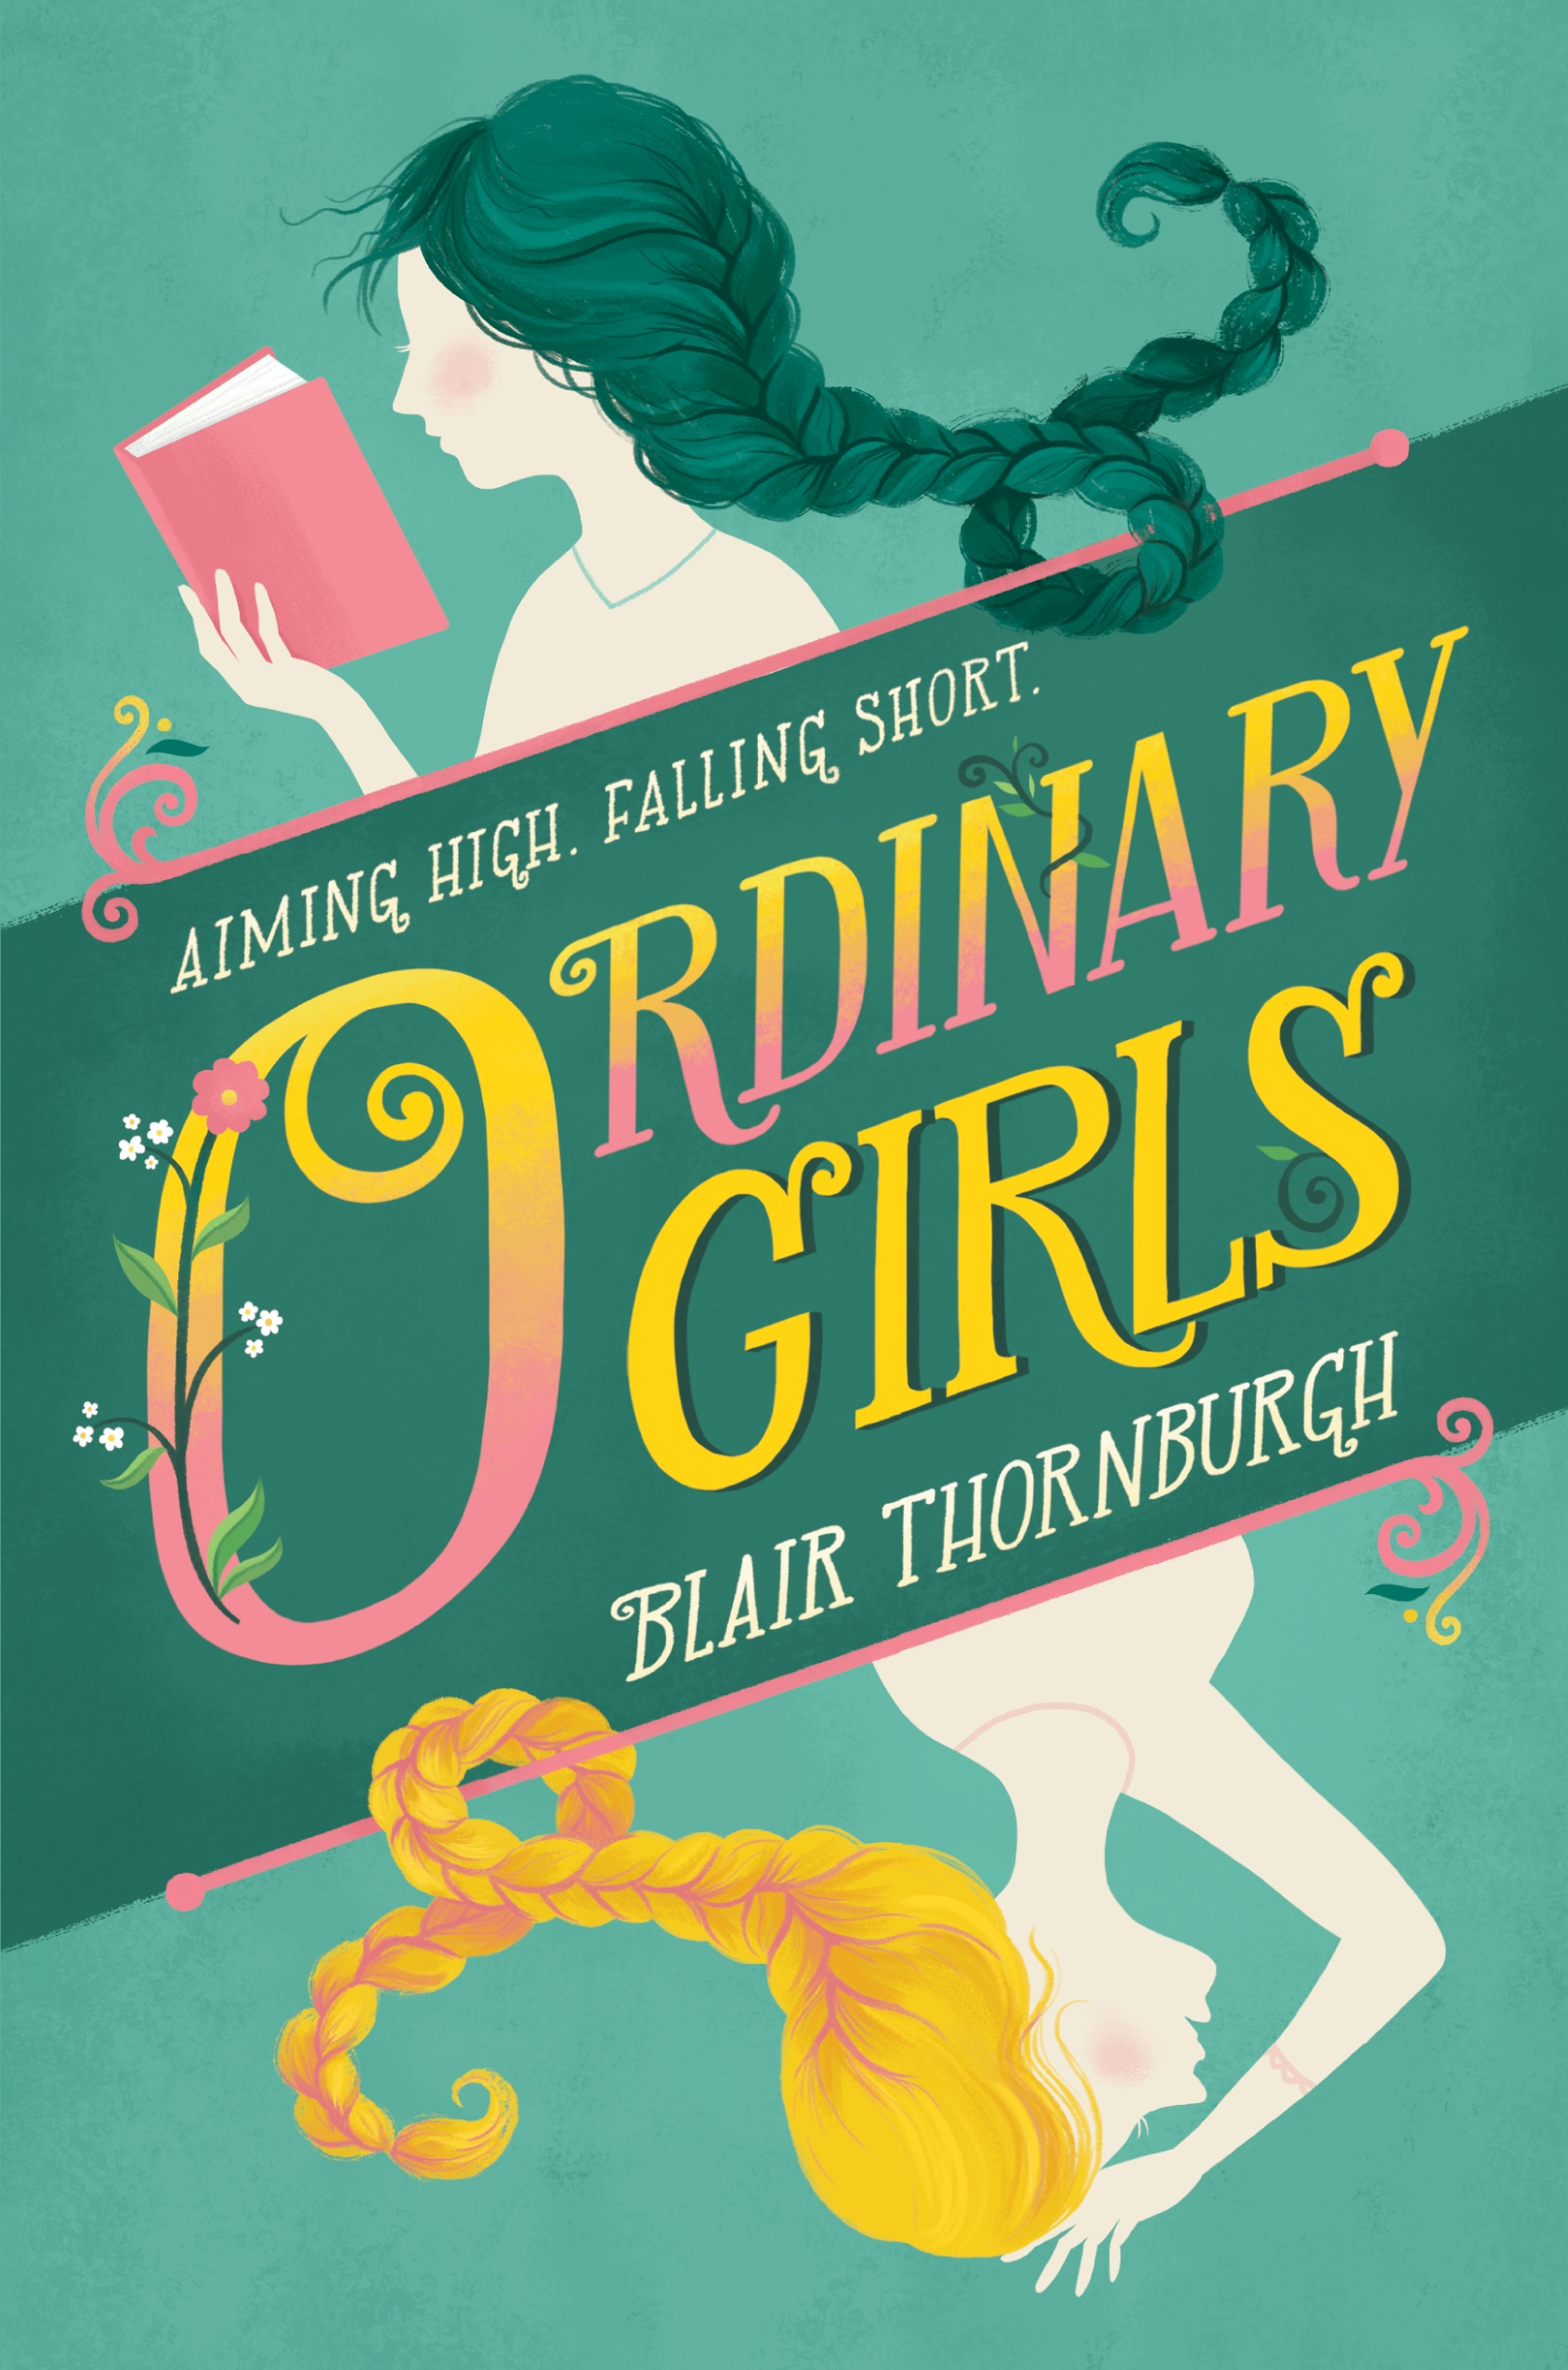Perfect for fans of Sarah Mlynowski and Jenny Han, this heartfelt and humorous contemporary take on *Sense and Sensibility* follows two sisters—complete opposites—who discover the secrets they’ve been keeping make them more alike than they’d realized.

For siblings as different as Plum and Ginny, getting on each other’s nerves is par for the course. But when the family’s finances hit a snag, sending chaos through the house in a way only characters from a Jane Austen novel could understand, a distance grows between them like never before.

Plum, a self-described social outcast, finally has something in her life that doesn’t revolve around her dramatic older sister. But what if coming into her own means Plum isn’t there for Ginny when she, struggling with a hard secret of her own, needs her most?

# Title Information

Age range: 14 and up

Hardcover, 368 pages

Coming June 4, 2019 from HarperTeen

**ISBN-10:** 0062447815

**ISBN-13:** 978-0062447814

Download book cover: [Image](http://www.blairthornburgh.com/wp-content/uploads/2018/10/OrdinaryGirls_HC_C-678x1024.jpg)

# Praise for *Ordinary Girls*

“[A] wise, funny, thoroughly contemporary coming-of-age tale.”  
—Kirkus (**starred review**)

“…as witty, intelligent, and perceptive as its narrator. A rewarding novel”  
—Booklist (**starred review**)

“A funny, beguiling story of sisterhood, burgeoning self-awareness, and first love.”  
—Publishers Weekly (**starred review**)

“A smart, character-driven contemporary novel with a timeless feel.”  
—School Library Journal

# What’s the Big Deal about Skulls?

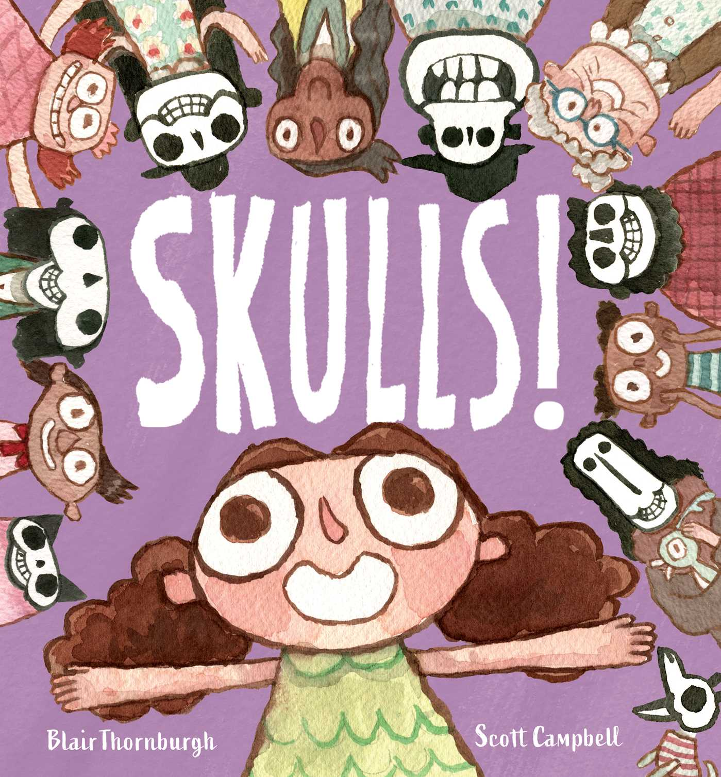

Debut picture book author Blair Thornburgh and award-winning illustrator Scott Campbell put their heads together to celebrate one of the most important bones in your body: the skull!  
  
You probably don’t think much about skulls.  
So what’s the big deal about them?  
  
Well, every head  
of every person  
you’ve ever seen  
has a skull inside.  
  
And that includes YOU!  
  
This smart, skull-positive story cheerfully dispels any fears kids might have about their skeletons, flipping our view of skulls from a spooky symbol to a fascinating, cool, and crucial part of our bodies.

# Title Information

Age range: Preschool – Second Grade

Hardcover, 40 pages

Coming July 23, 2019 from Atheneum Books for Young Readers

**ISBN-10:** 1534414002

**ISBN-13:** 978-1534414006

Download book cover: [Image](http://www.blairthornburgh.com/wp-content/uploads/2019/01/skulls_cover-624x672.jpg)

# From girl next door to the top of the charts…

A laugh-out-loud debut filled with hilarious awkward encounters, a supportive LGBTQ organization, and too many cheesy lyrics to count.  
  
Junior Nattie McCullough has always been that under-the-radar straight girl who hangs out in the cafeteria with her gay-straight alliance friends. She’s never been the girl that gets the guy, let alone the girl that gets a *hit song* named after her.

But when last summer’s crush, smoking-hot musician Sebastian Delacroix—who has recently hit the mainstream big-time—returns home to play a local show, that’s *just*what she gets. He and his band, the Young Lungs, have written a chart-topping single—“Natalie”—which instantly makes Nattie second guess everything she thought about their awkward non-kiss at that June pool party. That it was horrific. That it meant nothing. That Sebastian never gave her another thought.

To help keep her mind off of Sebastian and his maybe-about-her, maybe-not-about-her song, Nattie throws herself into planning the school’s LGBTQIA dance. That proves problematic, too, when Nattie begins to develop feelings for her good friend Zach. With the song getting major airplay and her once-normal life starting to resemble the cover of a gossip magazine, Nattie is determined to figure out once and for all if her brief moment with Sebastian was the stuff love songs are made of—or just a one-hit wonder.

# Title Information

Age range: 14 and up

Hardcover, 400 pages

Published July 11, 2017 from HarperTeen

**ISBN-10:** 0062447777

**ISBN-13:** 978-0062447777

Download book cover: [Image](http://www.blairthornburgh.com/wp-content/uploads/2013/02/WhosThatGirl-hc.jpg)

# Praise for Who’s That Girl

“Lively and smart, Blair Thornburgh’s debut will hook you like a pop song and proceed to win your heart.”  
*—*Nina LaCour, award-winning author of *We Are Okay*

“Blair Thornburgh’s debut is the perfect mixture of music and heart, friendship and romance. Like a classic song, Who’s That Girl will stick in your head long after the last page.”  
—Elizabeth Eulberg, author of *Better Off Friends*

“I should write a love song about how much I adore Blair Thornburgh’s fresh and funny debut. Charming, quirky, and full of heart.”  
—Sarah Mlynowski, *New York Times*bestselling author of *I See London, I See France*

“Clever dialogue […] a light, funny romance.”  
—Kirkus Reviews

“Thornburgh thoughtfully charts the tensions and loyalties among a solid group of friends […] sweetly offbeat and entertaining reading.”  
—Publishers Weekly

“Charmingly awkward and rooted in the bonds of friendship more than romance, this is a sweet, funny debut.”  
—Booklist

“The snappy dialogue, extremely likable characters, and daydream-worthy plot make this fun romance with Gilmore Girls–esque humor a perfect summer read.”  
—School Library Journal